**Project Phase-1**

**On**

**“CURATING AND COMPARING THE E-LEARNING DATASET FOR CHILDREN USING DEEP LEARNING”**



**Review-2 Report**

**SUBMITTED BY**

Mude Treyamsha Naik (322010306011)

Manepalli Nikhil Guneshwara (322010306044)

Rayala Sai Mohith (322010306006)

Dadam Likith Sai (322010306003)

Department of Computer Science and Engineering

SESSION: 2023 - 2024

*Under the guidance of*

Mrs.Sneha Sureddy

Designation

Assistant Professor

**Department of Computer Science and Engineering,**

**GITAM SCHOOL OF TECHNOLOGY (GST),**

**GITAM UNIVERSITY (DEEMED TO BE UNIVERSITY)**

**BENGALURU, KARNATAKA, INDIA**

**SEP 2023**

**Table of Contents**

**Chapter .No Title Page.No**

**1 Research Objective 3**

**2 Abstract 4**

**3 Literature survey 5**

**4 Design 10**

**4.1 Overall architecture 12**

**4.2 DFD (Level 0) 13**

**4.3 DFD (Level 1) 14**

1. **Objectives of the project**

The purpose of this project is to assess the engagement of a child during an online learning activity by predicting facial expressions. The ultimate goal is to develop an online learning module that can be integrated with facial engagement prediction. To achieve this, several factors will be considered, such as the type of learning activity, the type of facial expressions, the environment where the activity is taking place, and the age of the learner. We will also collect and train a separate student dataset and their applications in the educational setting. By analyzing the data and taking into account all the factors mentioned above, the project will be able to accurately predict a child's engagement during an online learning activity.

**2. Abstract**

This project addresses the critical issue of engagement detection in online learning environments. We have created a dedicated dataset containing information on students' engagement levels during online sessions, categorizing them as either engaged or disengaged. Leveraging deep learning concepts, particularly Convolutional Neural Networks (CNN), we train our manually curated dataset to develop a robust model for detecting student engagement.

Our approach aims to provide valuable insights for educators and learners by accurately identifying engagement levels during online sessions. By employing deep learning techniques like CNN, we intend to enhance the accuracy and effectiveness of engagement detection in online learning settings. This project has the potential to significantly improve the online learning experience by tailoring educational interventions based on real-time engagement feedback.

**3. Literature survey**

3.1 Paper-1

Title: Student Engagement Predictions in an e-Learning System and Their Impact on Student Course Assessment Scores

Authors: Mushtaq Hussain , Wenhao Zhu , Wu Zhang , and Syed Muhammad Raza Abidi

Year:2018

Summary of the paper: The study explores the prediction of student engagement levels within an e-learning system and investigates their influence on student course assessment scores. It aims to identify correlations between engagement metrics and academic performance. The findings shed light on the significance of active participation and its positive impact on student achievement, offering insights for educators to enhance e-learning experiences and outcomes.

Research gap:Collected data of students from an e-learning system (VLE) and formatted these data in a form suitable for input. Further examination can be done for children during e-learning.

3.2 Paper-2

Title:Assessing student engagement from facial behavior in on-line  learning

Authors:Paolo Buono,

Francesca D’Errico,Berardina De Carolis, Giuseppe Palestra

, Nicola Macchiarulo, Giuseppe Palestra

Year:2022

Summary of the paper:

This research examines the assessment of student engagement by analyzing facial behavior in online learning environments. By leveraging facial expressions and non-verbal cues, the study seeks to discern patterns indicative of student engagement levels. The findings contribute to the development of automated systems that can gauge and enhance online student engagement, ultimately improving the effectiveness of remote education.

Research gap:It is better to investigate and analyze how various engagement levels can be recognized from facial behavior during online lectures and it can be even extended for children.

3.3 Paper-3

Title:Predicting Student Engagement in the Online Learning Environment

Authors:Abdalganiy Wakjira, Samit Bhattacharya

Year:2019

Summary of the paper:

This research focuses on predicting student engagement in online learning settings. By employing data analytics and machine learning techniques, the study aims to forecast and identify factors that influence student participation and attentiveness. The outcomes can empower educators to intervene proactively and create more engaging online learning experiences, leading to improved student outcomes and retention rates.

Research gap:The model was based on 9 significant features, but not the most important features. The relative importance of the features was not determined. Future research might also analyze other factors of engagement.

3.4 Paper-4

Title:Engagement detection in online learning: a review

Authors:M. Ali Akber Dewan*, Mahbub Murshed and Fuhua Lin

Year:2019

Summary of the paper:

This review delves into the topic of engagement detection in online learning. It provides an overview of existing research and methodologies for identifying and measuring student engagement in digital educational settings. By analyzing various techniques such as data analytics and machine learning, the review aims to offer insights into the state of the field and potential areas for improvement in online learning platforms. Understanding and enhancing student engagement is crucial for optimizing online education outcomes.

Research gap:Although computer vision-based technologies have proven promising in identifying engagement, they have significant drawbacks. To make training easier, we construct a fresh child dataset.

3.5 Paper-5

Title:Student-Engagement Detection in Classroom Using Machine Learning Algorithm

Authors: Nuha Alruwaisand Mohammed Zakariah

Year:2019

Summary of the paper:

This study focuses on detecting student engagement levels in traditional classrooms using machine learning algorithms. It explores the use of data from various sources such as attendance records, participation, and feedback to classify and assess student engagement. The research aims to create predictive models that can identify students who may be disengaged, allowing educators to intervene and improve overall learning outcomes. By leveraging machine learning, this approach has the potential to enhance classroom experiences and increase student success.

Research gap:In future, we intend to examine other aspects of students’ engagement analytics in the VLE, such as their learning preferences.

3.6 Paper-6

Title:Automatic Engagement Level Estimation of Kids in a Learning Environment

Authors: Woo-Han Yun, Dongjin Lee, Chankyu Park, and Jaehong Kim

Year:2015

Summary of the paper:

This study focuses on the development of an automated system for estimating the engagement levels of children in a learning environment. By employing various sensors and data analysis techniques, it aims to accurately gauge students' levels of involvement and attentiveness during educational activities. The research findings hold promise for enhancing pedagogical strategies, enabling educators to tailor their teaching methods to better engage young learners and optimize their educational experiences.

Research gap:Future studies will examine aspects of time associated with student Tutoring, mentor presence, and the effectiveness of online sessions.

3.7 Paper-7

Title: E-Learning Engagement through Convolution Neural Networks in Business Education

Authors: Arshi Nai

Year:2022

Summary of the paper:

explores the integration of CNNs in online education. The study investigates how CNNs can enhance engagement by analyzing multimedia content and personalizing learning experiences. It presents experimental results demonstrating the effectiveness of this approach. The findings suggest that CNNs have the potential to improve e-learning outcomes in the business education sector. Further research in this area could revolutionize online business education.

Research gap:In future, we intend to examine other aspects of students’ engagement analytics in the VLE, such as their learning preferences.

3.8 Paper-8

Title: Application of Deep Learning on Student Engagement in e-learning environments

Authors: Prakhar Bhardwaj , P.K. Gupta , Harsh Panwar , Mohammad Khubeb Siddiqui, Ruben Morales-Menendez, Anubha Bhaik

Year: 2021

Summary of the paper:

This systematic review examines automatic engagement estimation in smart education/learning settings. It investigates various definitions of engagement, available datasets, and methods used in the field. The study provides insights into the diverse approaches employed to measure engagement in technology-enhanced learning environments. By analyzing these factors, it contributes to our understanding of how engagement is assessed and offers valuable guidance for future research in the field of smart education.

Research gap:Finally, the proposed system can be used by teachers or school administrations to find whether students are actively engaged or not. However, issues related to environmental constraints of a student such as head poses, illumination variations, and health beat monitoring can also be taken into consideration in the future

3.9 Paper-9

Title: Automatic Student Engagement in Online Learning Environment Based on Neural Turing Machine

Authors: Xiaoyang Ma, Min Xu, Yao Dong, and Zhong Sun

Year:2021

Summary of the paper:

This research delves into automatic student engagement detection in online learning using Neural Turing Machines (NTMs). NTMs, a type of neural network with memory, are employed to analyze students' interactions and activities within the online environment. The study aims to predict and enhance student engagement levels by leveraging the power of NTMs' memory and computation capabilities. The findings indicate that this approach can provide real-time insights into student engagement, aiding educators in optimizing online learning experiences. This innovative use of NTMs holds promise for personalized e-learning interventions.

Research gap:No outcomes about engagement prediction has been specified and How does engagement estimation improve learning outcomes? So using specified real time detection is preferable.

3.10 Paper-10

Title: Facial emotion recognition based real-time learner engagement detection system in online learning context using deep learning models

Authors: Swadha Gupta· Parteek Kumar· Raj Kumar Tekchandani

Year:2022

Summary of the paper:

The facial emotion recognition-based real-time learner engagement detection system for online learning utilizes deep learning models to analyze students' facial expressions during virtual classes. These models identify emotions like happiness, boredom, or confusion, allowing educators to gauge learner engagement instantly. This system enhances online teaching by providing timely feedback on student interest and comprehension, ultimately improving the overall learning experience.

Research gap:we'll explore key features for assessing student engagement in multi-modal data and their correlation with accuracy. We'll also consider incorporating an LSTM network for improved time signal analysis in our model.

3.11 Paper-11

Title: An intelligent system for monitoring students' engagement in large classroom teaching through facial expression recognition

Authors: Chakradhar Pabba | Praveen KumarF

Year:2021

Summary of the paper:

Create an intelligent system using facial expression recognition to track student engagement in large classrooms. Collect and process data, training machine learning models for real-time recognition of emotions and engagement levels. Offer teachers insights through engagement metrics while upholding privacy and ethical standards. Continuously refine the system for better classroom management.

Research gap:Collect more dataset images and train them according to the label. Future research will focus on other student engagement data in the dataset, like their preferred learning styles.

3.12 Paper-12

Title: A new ML-based approach to enhance student engagement in online environment

Authors: Sarra Ayouni1 *, Fahima HajjejID1 , Mohamed Maddeh2 , Shaha Al-Otaibi1

Year:2021

Summary of the paper:

This paper introduces a novel machine learning (ML) approach to boost student engagement in online education. It employs predictive models to identify at-risk students and provides personalized recommendations. The ML system offers real-time feedback to instructors, aiding proactive interventions. Data privacy and ethical considerations are emphasized. While challenges exist, this approach holds promise for improving online learning outcomes.

Research gap:

Enhance FER model accuracy via dataset expansion and boost robustness by incorporating head pose, gaze, and academic affective states for group engagement estimation.

4. Design

4.1 Overall Architecture

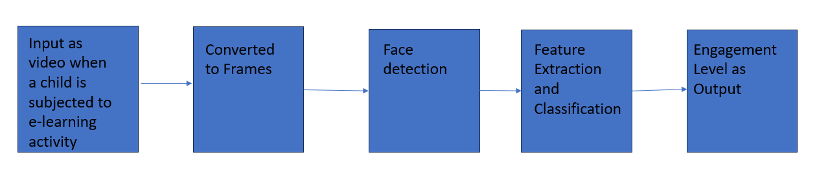

4.2 DFD (Level 0)

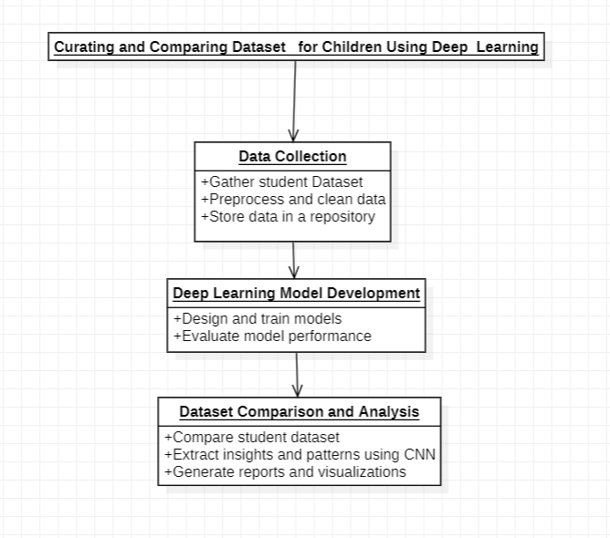

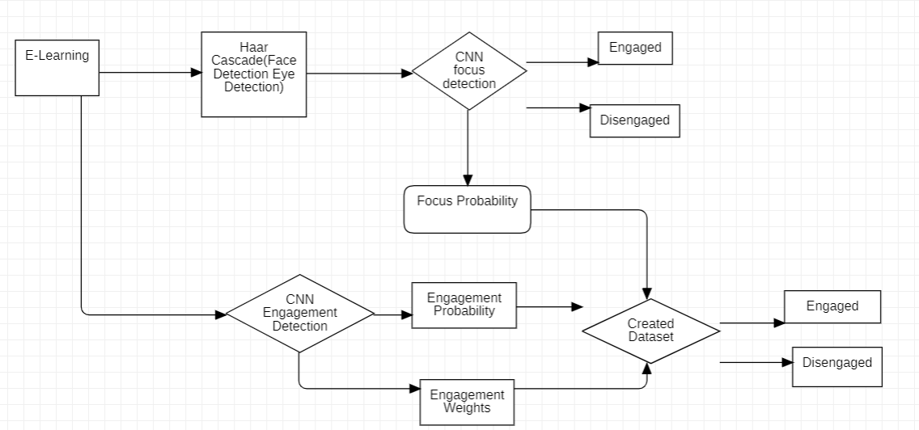

DFD(Level 1)

4.3 UML(Class Diagram)

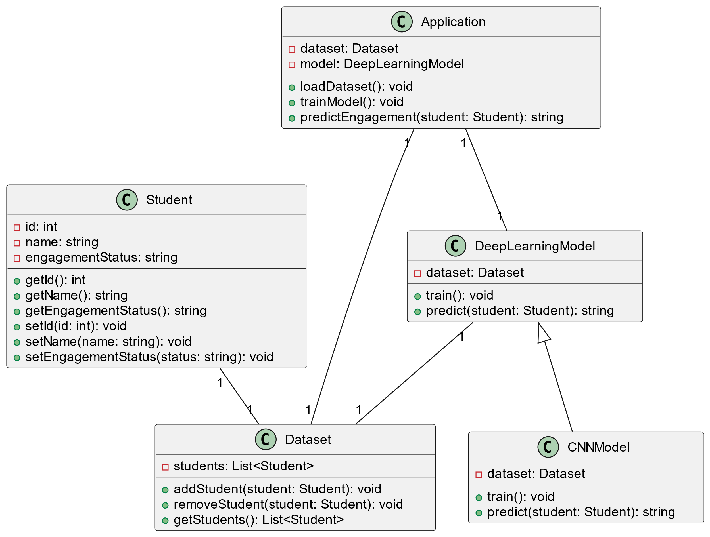

Use Case Diagram

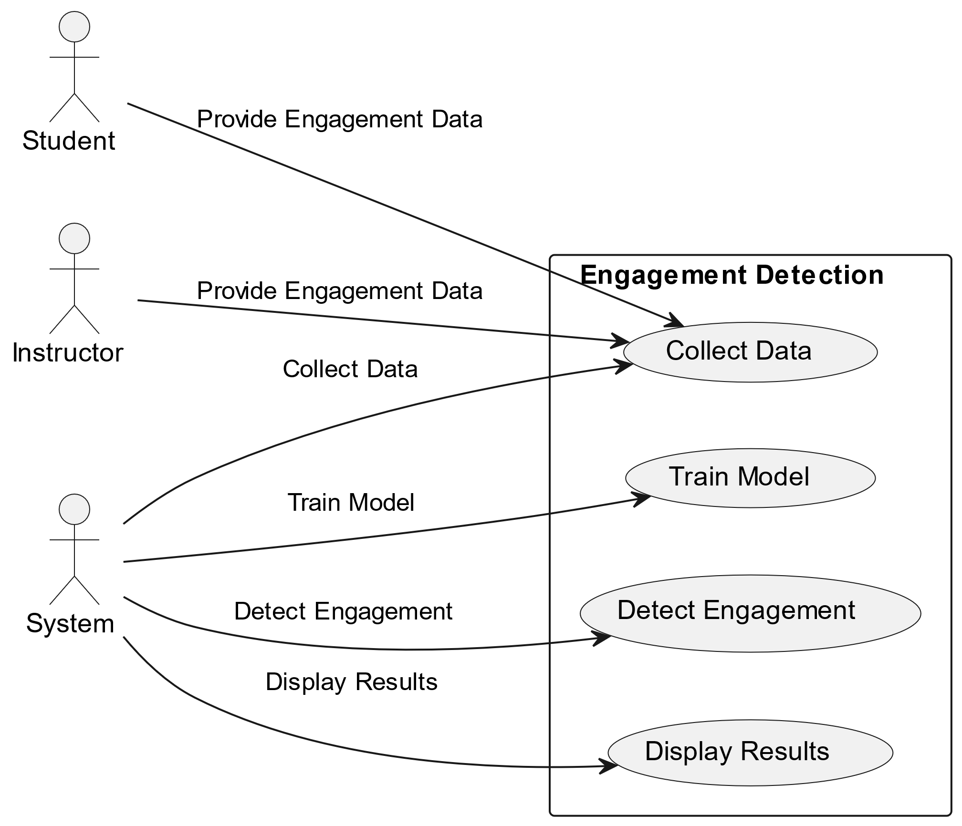

**5. Hardware and Software Requirements**

Nvidia GPU

Alexnet

MATLAB

**6. Modules**

**List of modules with description**

**1.**When children are subjected to an e-learning activity as part of instruction, a video of the child is captured.

**2**.With additional pre-processing, the movie was transformed into a series of frames.

**3.**Face detection will be performed after the frames have been processed, and the results will be sent to the Convolutional Neural Network.

**4.**The trained model extracts features and outputs a categorization of engagement, which aids in determining if the child is engaged in a particular learning activity.

**5**.we considered six classes for our dataset and we collected the kids dataset and tried to train them but they resulted very low accuracy and now we are trying to modify the dataset accordingly

**7.IMPLEMENTATION**

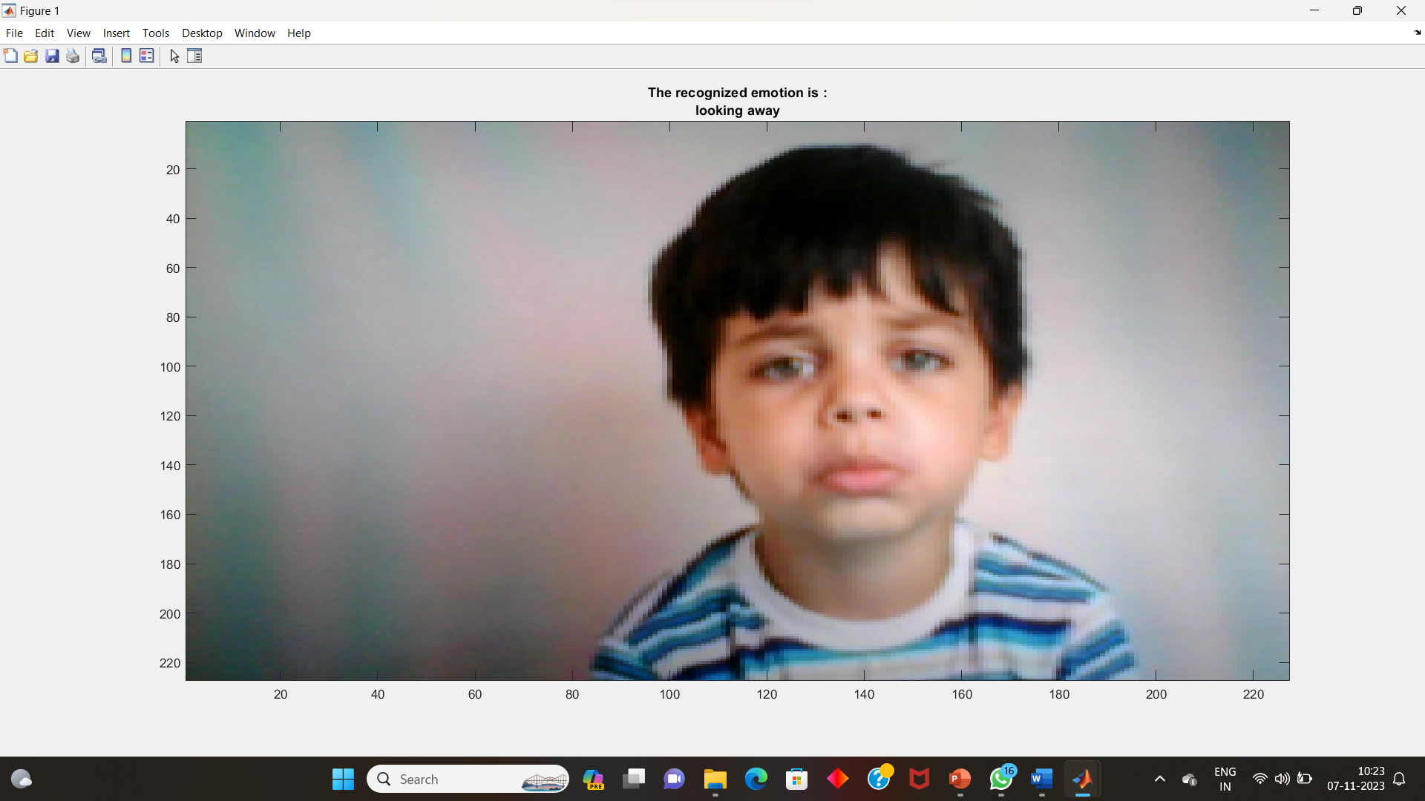

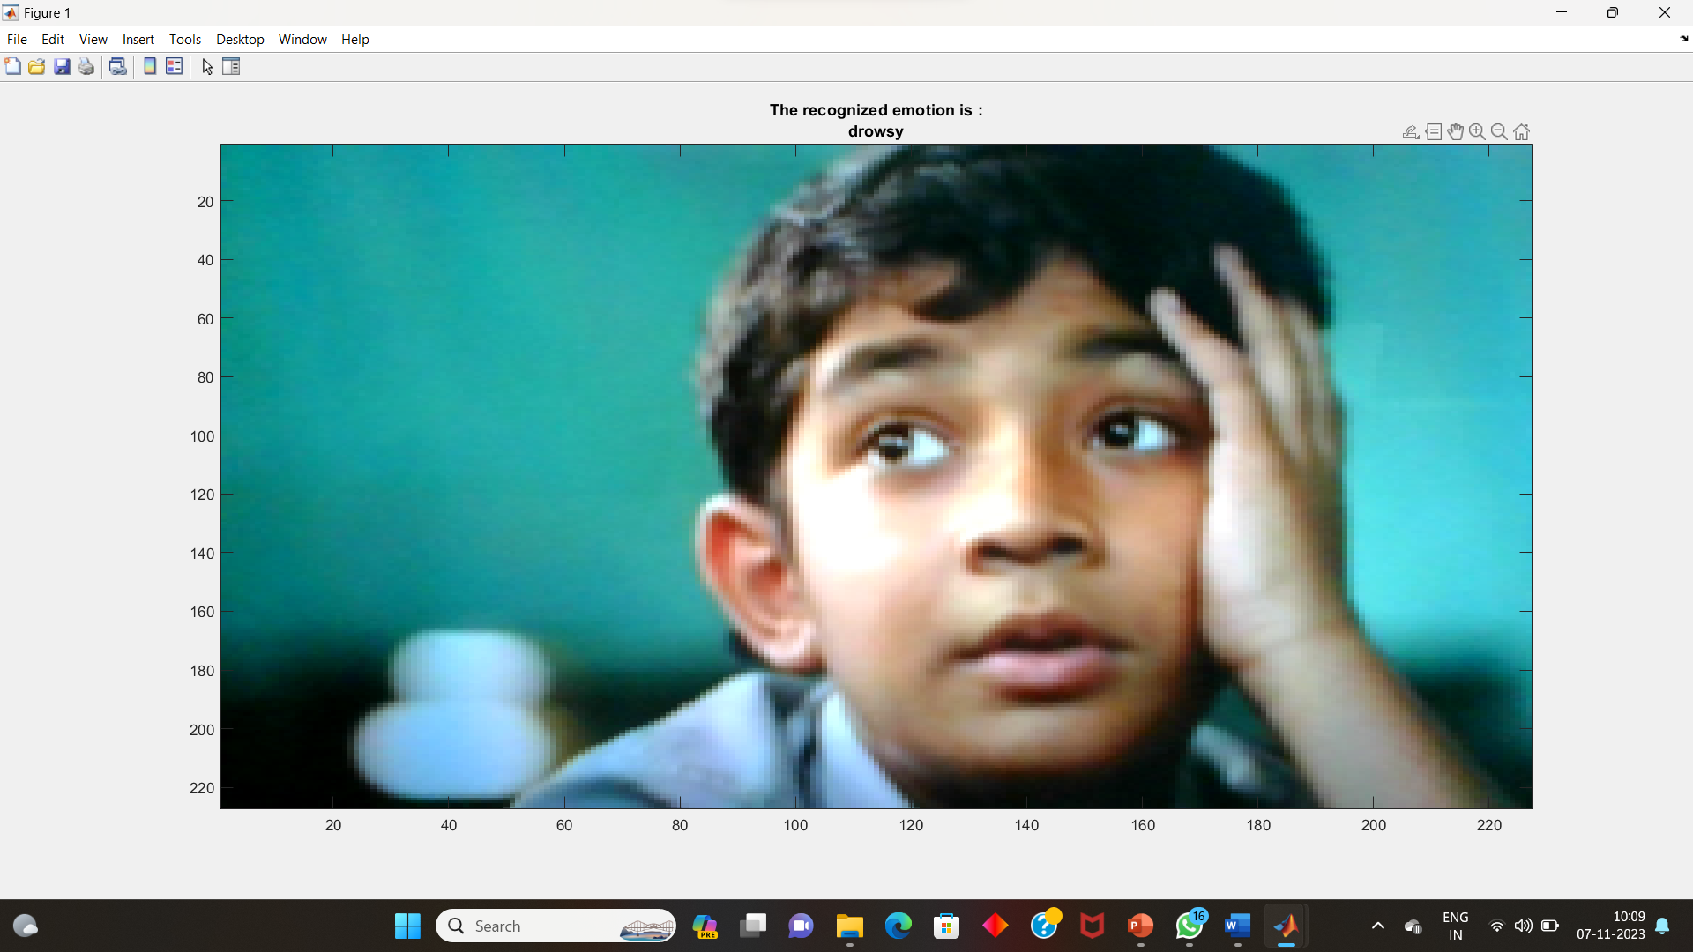

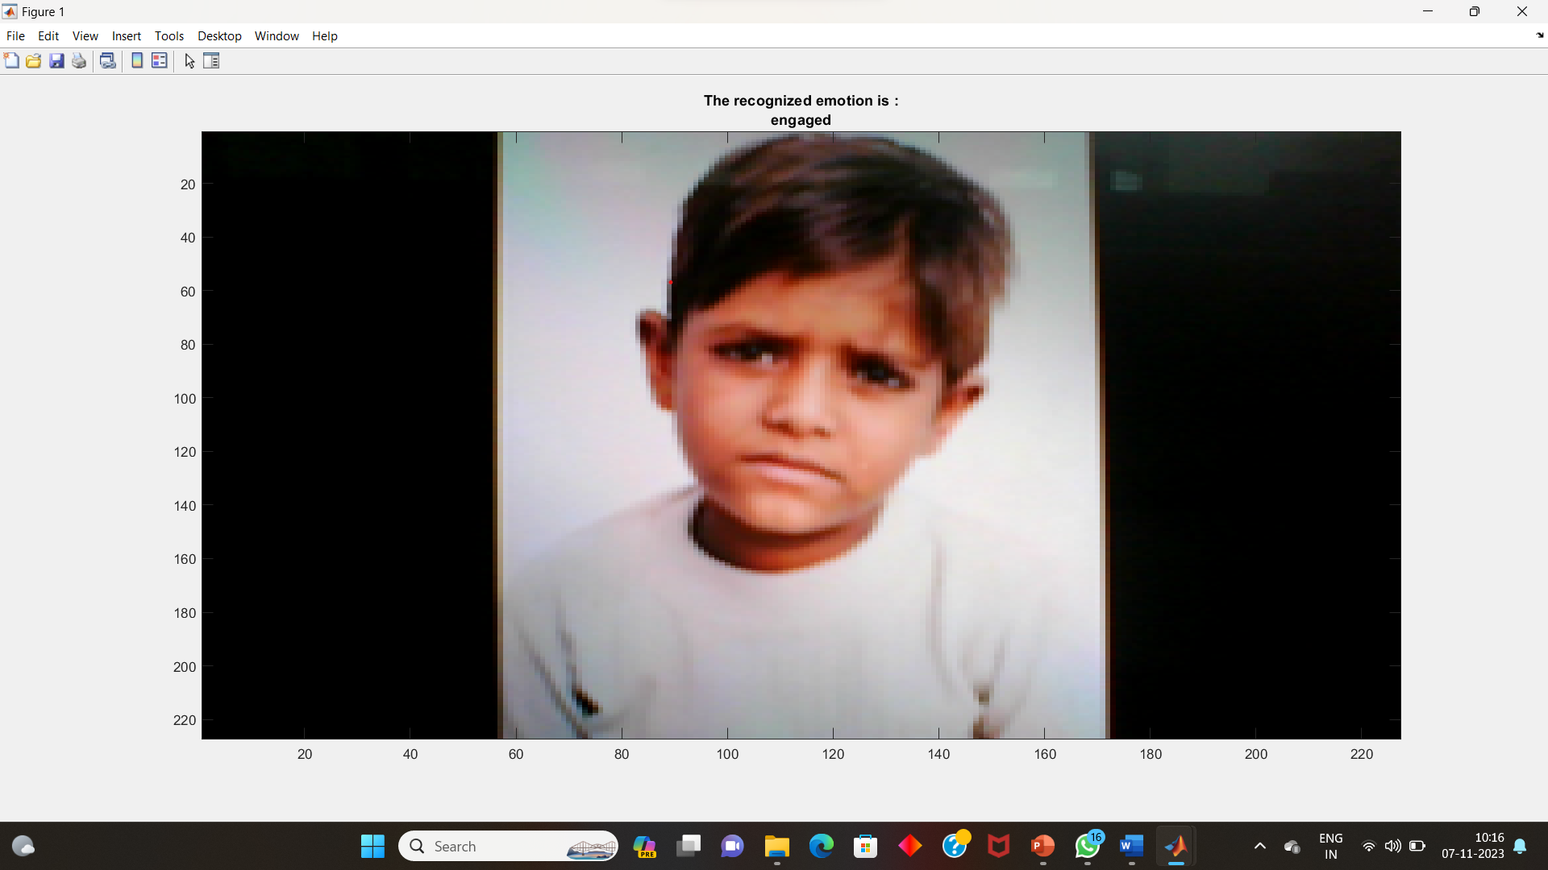

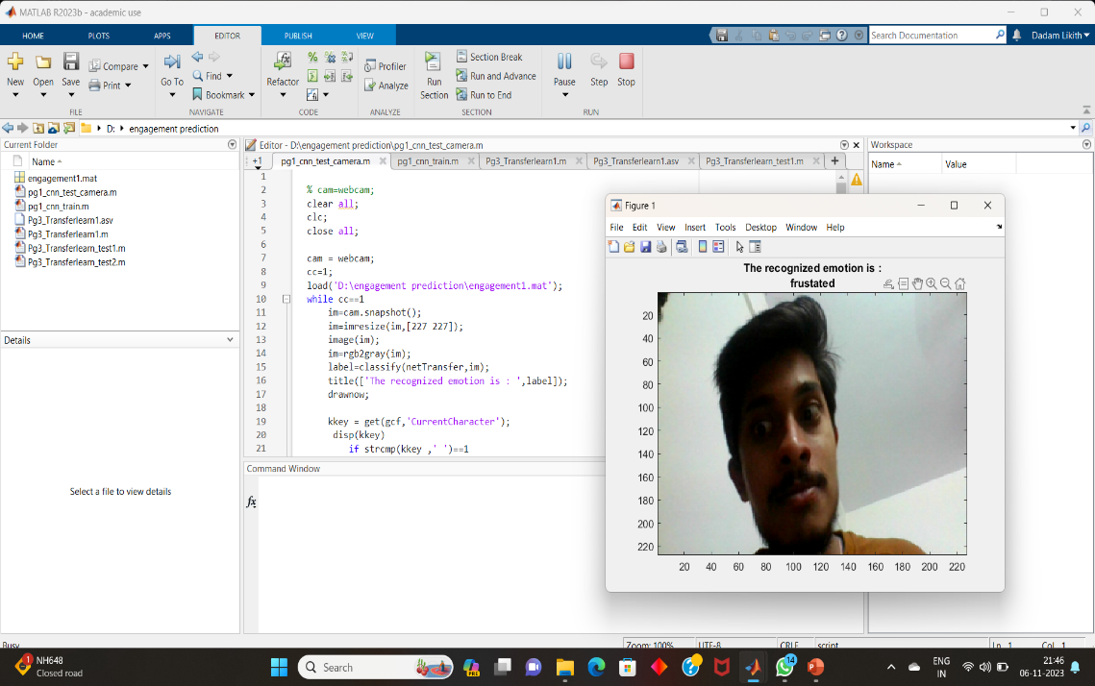  
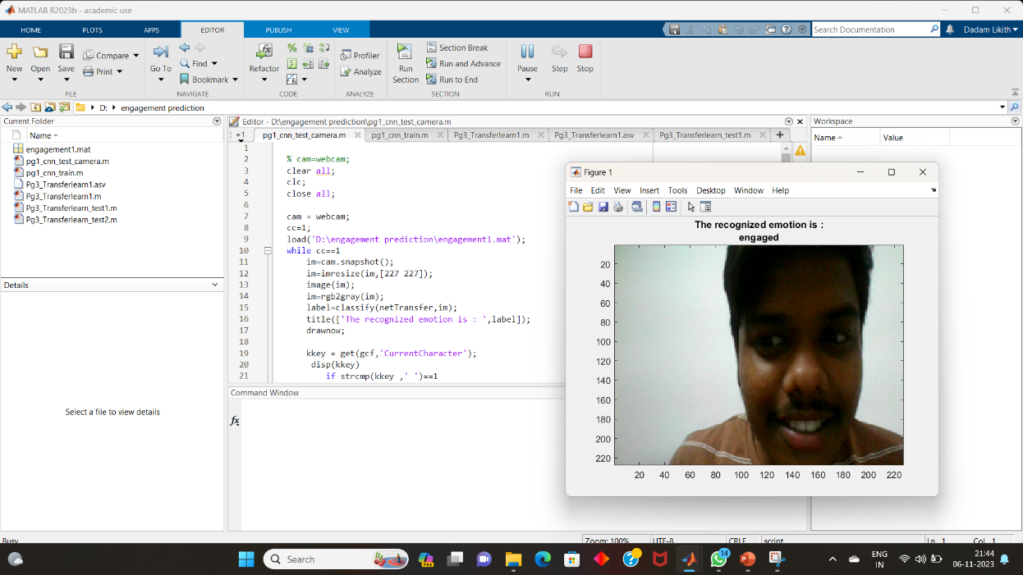

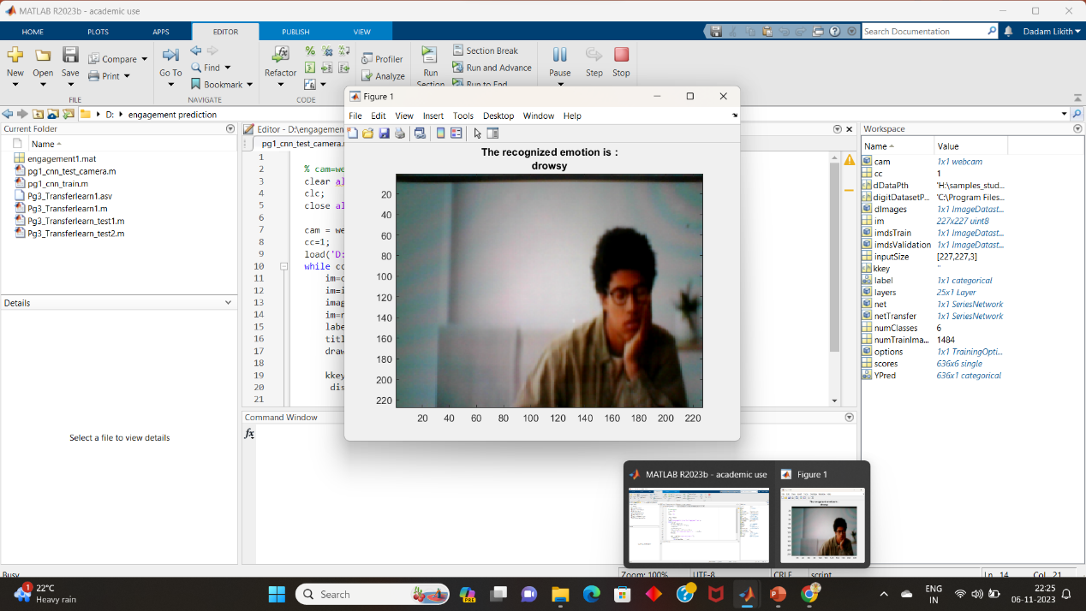

**References**

<https://www.researchgate.net/publication/328047557_Student_Engagement_Predictions_in_an_e-Learning_System_and_Their_Impact_on_Student_Course_Assessment_Scores>

<https://link.springer.com/article/10.1007/s11042-022-14048-8>

<https://www.igi-global.com/article/predicting-student-engagement-in-the-online-learning-environment/287095>

<https://slejournal.springeropen.com/articles/10.1186/s40561-018-0080-z>

<https://www.mdpi.com/2079-9292/12/3/731>

<https://www.researchgate.net/publication/279166384_Automatic_Engagement_Level_Estimation_of_Kids_in_a_Learning_Environment>

<https://inovatus.es/index.php/ejine/article/view/437>

<https://www.sciencedirect.com/science/article/pii/S0045790621002597>

<https://slejournal.springeropen.com/articles/10.1186/s40561-022-00212-y>

<https://www.researchgate.net/publication/349056234_Automatic_Student_Engagement_in_Online_Learning_Environment_Based_on_Neural_Turing_Machine>

<https://link.springer.com/article/10.1007/s11042-022-13558-9>

<https://www.researchgate.net/publication/355359025_An_intelligent_system_for_monitoring_students'_engagement_in_large_classroom_teaching_through_facial_expression_recognition>

<https://www.researchgate.net/publication/356115204_A_new_ML-based_approach_to_enhance_student_engagement_in_online_environment>

**Drive Link of Kids Dataset**

<https://drive.google.com/drive/folders/1Gnmd6pAFX7tYvuAtfP3bx_23NIhMZ8T1?usp=sharing>